**Project Development Phase**  **Model Performance Test**

|  |  |
| --- | --- |
| Date | 21 November 2022 |
| Team ID | PNT2022TMID14007 |
| Project Name | Emerging methods for early detection of forest fires. |
| Maximum Marks | 10 Marks |

**Model Performance Testing:**

Project team shall fill the following information in model performance testing template.

|  |  |  |  |
| --- | --- | --- | --- |
| **S.No.** | **Parameter** | **Values** | **Screenshot** |
| 1. | Model Summary | Total params: 896  Trainable params: 896  Non-trainable params: 0 |  |
| 2. | Accuracy | Training Accuracy – 12.68  Validation Accuracy – 13.07 |  |

**Model Summary**

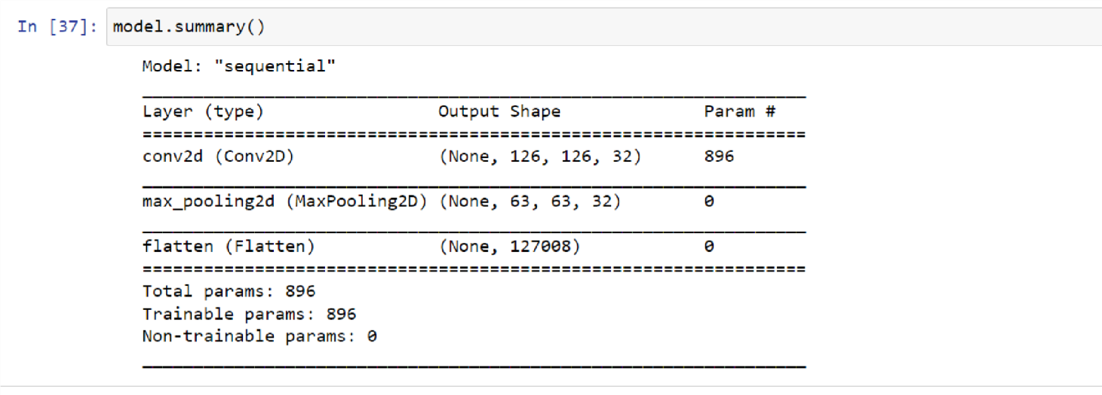

**Accuracy**

